**SHELL SCRIPTING DOCUMENT**

Creating directory and files

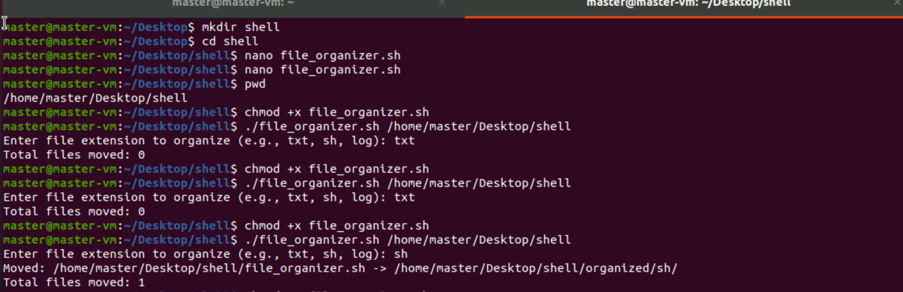

Viewing in file editor

